Classification is a type of supervised machine learning where the goal is to predict a categorical label (a class) for new data based on past examples.
Decision tree is a type of supervised algorithm (having a pre-defined target variable) that is mostly used in classification problems. It works for both categorical and continuous input and output variables.
Decision Table and Decision Tree
Applicant | Income | Credit Score | Employment | Loan Approved
A | High | Good | Stable | Yes
B | Low | Poor | Unstable | No
C | Medium | Good | Stable | Yes
D | Low | Good | Stable | Yes
E | Medium | Poor | Unstable | No

Decision Tree

Credit Score
/ \
Good Poor
/ \
Employment Loan = No
/ \
Stable Unstable
| |
Loan=Yes Loan=No

Gini purity:-

Gini purity is a measure used in decision trees to tell how “pure” (homogeneous) a node is.

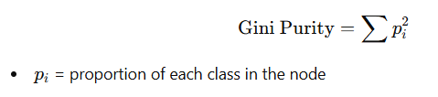

Example

Case 1: Pure node
- Yes = 10, No = 0
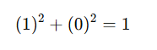
Gini purity = 1 (perfect)

Case 2: Mixed node
- Yes = 5, No = 5

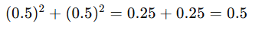
Less pure

Suppose we have three features/node and two classes
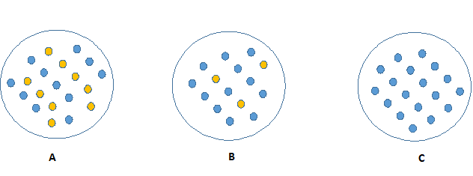

Let’s convert the three circles (A, B, C) into the same format as your previous example and compute Gini purity.

Step 1: Count points from image

A:
- Blue = 12
- Yellow = 8
- Total = 20

B:
- Blue = 16
- Yellow = 4
- Total = 20

C:
- Blue = 20
- Yellow = 0
- Total = 20

Step 2: Convert to Dataset Format
Group | Blue | Yellow | Total
A | 12 | 8 | 20
B | 16 | 4 | 20
C | 20 | 0 | 20

Step 3: Calculate Gini Purity

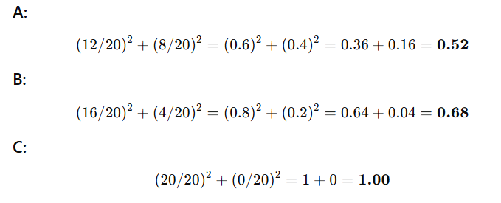

Step 4: Final Comparison
Group | Gini Purity
A | 0.52
B | 0.68
C | 1.00

Conclusion
- C → Perfectly pure (only one class)
- B → More pure than A
- A → Most mixed (least pure)

Calculate Gini Purity for Loan data:

Step 1: Parent Node
Total = 5
- Yes = 3 (A, C, D)
- No = 2 (B, E)
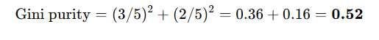

Step 2: Split on Income

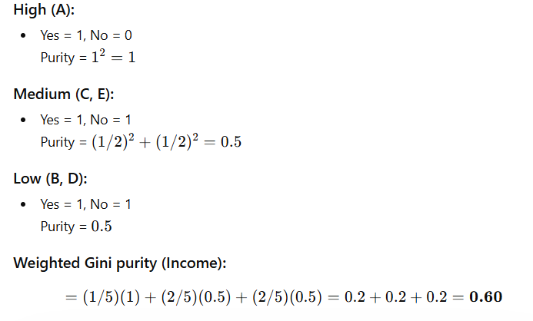

Step 3: Split on Credit Score

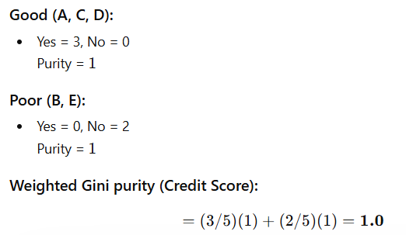

Step 4: Split on Employment

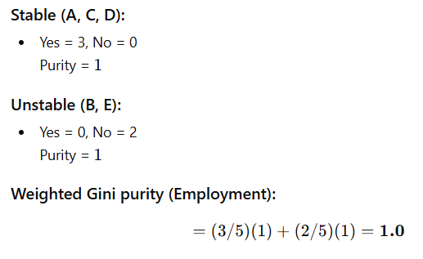

Final Comparison
Split | Gini Purity
Income | 0.60
Credit Score | 1.00
Employment | 1.00

Final Answer
Best split = Credit Score OR Employment
- Both give perfect purity (1.0)
- They completely separate Yes vs No

Evaluation/Metrics:-
Confusion Matrix –
To measure the performance of our models above, we need confusion matrix. The confusion matrix is used for checking whether the predictors are truly classified into correct classes.

Confusion Matrix Terms
- Positive = Loan Approved (Yes)
- Negative = Loan Not Approved (No)

⚫ True Positive (TP)
👉 Applicant correctly predicted as Approved
- Model says: Yes
- Actual: Yes
️ Loan given to someone who should get it

⚫ True Negative (TN)
👉 Applicant correctly predicted as Not Approved
- Model says: No
- Actual: No
️ Loan rejected for someone who should not get it

⚫ False Positive (FP)
👉 Applicant incorrectly predicted as Approved
- Model says: Yes
- Actual: No
Loan given to someone who should NOT get it
(Risky — possible default)

⚫ False Negative (FN)
👉 Applicant incorrectly predicted as Not Approved
- Model says: No
- Actual: Yes
Loan rejected for someone who deserves the loan
(Lost business opportunity)

Quick Mapping Table
Term | Meaning in Loan Context
TP | Correctly approved
TN | Correctly rejected
FP | Wrongly approved
FN | Wrongly rejected

Real-World Insight
- FP is more dangerous → bank loses money
- FN is less dangerous → bank loses opportunity

False Positive (FP) can be defined as Type 1 error and False Negative (FN) can be defined as Type 2 error.
We also need other metrics:
• Accuracy = (TP +TN) / (TP + TN + FP +FN)
• Precision = TP / (TP + FP)
• Recall (Sensitivity)=TP / (TP + FN)
• F1 score = 2 x ((Precision x Recall) / (Precision + Recall))
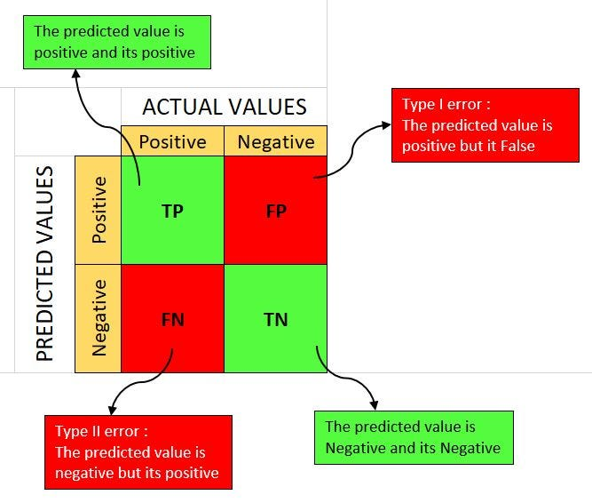

Other classification algorithm:-
- Random Forest
- Naive Bayes
- Support Vector Machines
- K-Nearest Neighbors
- Gradient Boosting

